**Year 11 General Human Biology**

**Task 2: Supervised written – Cell reproduction, reproductive systems and pregnancy (10%)**

RESULT

/ 37

**Task 2**

**TYPE:** Supervised Written

**CONTENT:** Cell reproduction, reproductive systems and pregnancy

**WEIGHTING:** 10%

**Student Name: ­­­­­­­­­­____________________________**

**Due date: ___ / ___ / ______**

**Teacher:** Mrs Cunningham

**CONDITIONS:**

Must be completed under test conditions in class. This task will be competed individually.

50 minutes allocated

37 Marks

**TASK DETAILS:**

This task contains **four** questions with a number of parts to assess the student’s understanding of the content from the science understanding topics cell reproduction, reproductive systems and pregnancy.

Notes/reference materials may not be used during this task.

This task contains a number of question types. You could be required to:

* provide single word, sentence or short paragraph responses
* provide responses making connections, drawing conclusions, constructing arguments, analysing and/or evaluating information.

Your responses may incorporate labelled diagrams or tables with explanatory notes.

**Answer all questions in the spaces provided. (TOTAL 37 marks)**

Question 1 (TOTAL 7 marks)

The diagram below shows the structures of deoxyribose nucleic acid (DNA).

1. On the diagram above, write the missing base to complete each base pair. (2 marks)
2. On the diagram above, label the following structures:
3. a sugar molecule (1 mark)
4. a phosphate molecule (1 mark)
5. hydrogen bonds. (1 mark)
6. Circle the correct answer to complete the sentences below. (2 marks)
7. The double helix describes the shape of

DNA                              chromosomes

1. The region on a chromosome that contains the code for a trait an organism inherits is a

gene                                 mitosis

Question 2 (TOTAL 11 marks)

Cell division plays a critical role in cellular growth, development and reproduction.

The diagram below shows the phases of mitosis, however, they are not in the correct order.

**D**

**C**

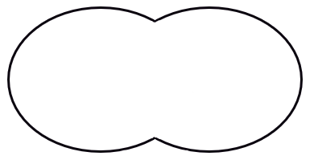

**A**

**B**

**E**



1. List the letters A to E in the order that represents the phases of mitosis correctly. (1 mark)

______________________________________________________________________________

Sexual reproduction requires the production of gametes



1. Define the term ‘gamete’. (1 mark)

______________________________________________________________________________

______________________________________________________________________________

Gametes are produced by the process of meiosis. This process produces a cell that is haploid.

1. State what the term ‘haploid’ means. (1 mark)

______________________________________________________________________________

______________________________________________________________________________

Human cells contain two sex chromosomes and 22 autosomal chromosomes.

1. Use the information above about humans to complete the following table. (2 marks)

|  |  |
| --- | --- |
|  | Adult female |
| Total number of chromosomes in each body cell |  |
| Total number of chromosomes in each gamete |  |

1. Use the table below to outline three differences between mitosis and meiosis. (6 marks)

|  |  |  |
| --- | --- | --- |
|  | Mitosis | Meiosis |
| 1 |  |  |
| 2 |  |  |
| 3 |  |  |

Question 3 (TOTAL 13 marks)

The diagram below shows the structure of the male reproductive system.

1. Refer to the diagram above to complete the table below. (4 marks)

|  |  |  |
| --- | --- | --- |
| **Label** | **Name of structure** | **Function of structure** |
| **A** |  |  |
| **D** |  |  |
|  |  | Carries sperm to the urethra |

Both males and females produce follicle stimulating hormone (FSH) and luteinising hormone (LH).

1. Which organ is responsible for the production of these hormones? (1 mark)

__________________________________________________________________________

1. Identifying the target organ or cells for each of these hormones and state their effect on the male reproductive system. Write your answers in the table below. (4 marks)

|  |  |  |
| --- | --- | --- |
| **Hormone** | **Target organ or cells** | **Effect on male reproductive system** |
| FSH |  |  |
| LH |  |  |

Use the key below to answer the following questions (d) and (e).

|  |  |
| --- | --- |
| **2n** | Total genetic material of a human cell |
| **n** | One half to the total genetic material in a human cell |

1. Choose which of the following representation shows correctly what happens to chromosome numbers during the process of fertilisation. (1 mark)

Option one

**n**

**2n**

**2n**

**+ 🡪**

Option two

**n**

**2n**

**2n**

**+ 🡪**

Option three

**n**

**n**

**2n**

**+ 🡪**

Option four

**4n**

**2n**

**2n**

**+ 🡪**

The correct option is: __________________________________________________________________________

1. Justify your choice in question (d). (3 marks)

__________________________________________________________________________

__________________________________________________________________________

__________________________________________________________________________

__________________________________________________________________________

__________________________________________________________________________

__________________________________________________________________________

Question 4 (TOTAL 6 marks)

The following diagram is that of a pregnancy at approximately 18 weeks gestation.

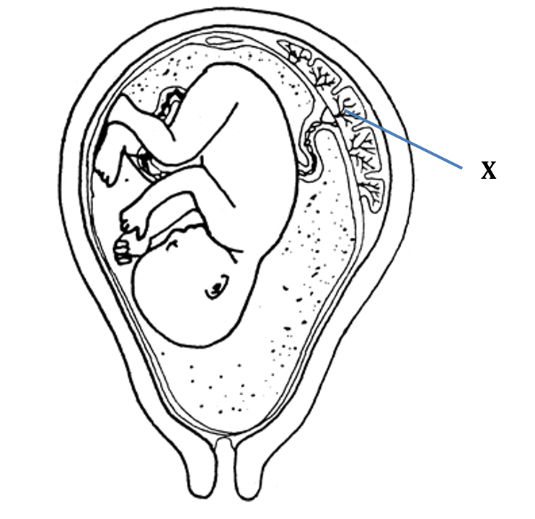

1. Circle the anatomical term that best describes the baby at this stage of gestation. (1 mark)

blastocyst embryo foetus

1. Identify structure X. (1 mark)

___________________________________________________________________________

1. Explain how structure X is suited to the function it performs. (4 marks)

___________________________________________________________________________

___________________________________________________________________________

___________________________________________________________________________

___________________________________________________________________________

___________________________________________________________________________

___________________________________________________________________________

___________________________________________________________________________

**END OF ASSESSMENT**